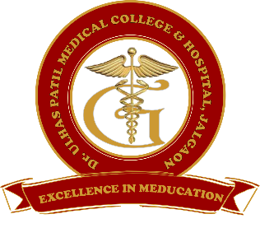**GODAVARI FOUNDATION’S**

**DR. ULHAS PATIL MEDICAL COLLEGE & HOSPITAL,**

**RECOGNIZED BY MEDICAL COUNCIL OF INDIA, APPROVED BY CENTRAL GOVT. OF INDIA, NEW DELHI,**

**LETTER NO. MCI-34(41)/2012-MED./158127, DATED 05/02/2013**

**AFFILIATED TO MAHARASHTRA UNIVERSITY OF HEALTH SCIENCES, NASHIK [COLLEGE CODE-1306]**

**JALGAON-BHUSAWAL ROAD, NH-6, JALGAON KH, TAL.& DIST. JALGAON 425309**

**TEL. NO. (0257)2366657, 2366678 FAX NO. 0257-2366648**

**EMAIL ID :**[**DUPMCJ@YAHOO.IN**](mailto:dupmcj@yahoo.in) **WEB SITE :** [**WWW.DUPMC.AC.IN**](http://www.dupmc.ac.in)

**2.3.3 Teachers use ICT-enabled tools for effective teaching and learning process, including online- e resources**

In order to provide students with a high-quality education, faculties are adapting to the usage of ICT technology. Following various ICT enable teaching learning practices are followed in the institute with the help of available ICT tools/facilities

* Provision of sufficient number of computers with internet connectivity, audio video facility
* High speed internet facility with LAN connection in class rooms and laboratories
* Use MOOC Platform like NPTEL, Edux etc. are available
* Digital Library resources like K-Hub, NDL, videos and presentations
* Wi-fi facility in the campus
* Desktop / Laptop available in the faculty cabin and class rooms
* Scanners- Scanners are available, faculty uses the facility for development of scan images used in teaching and learning processes

**Use of ICT by Faculty:**

* Conducting classes through Google meet platform and Google Class rooms during pandemic situations
* Use of computers and software for Examination and evaluation of CO and PO attainment
* Developing learning videos
* Use of Virtual labs
* Use of power point presentations and Videos with LCD projector facility
* Use of e-resources such as K-Hub, NPTEL videos, Presentations
* Arranging virtual visits in addition to actual visits
* Arranging online experts/guest lectures
* Conducting online examinations
* Arranging clinical webinars / demonstration videos
* Dissemination of teaching learning material through electronic media like whats-app, e-mail, Google drive, Google class room etc.
* Class room audio system

**Dean Chairman**

**Dr. Ulhas Patil Medical College Dr. Ulhas Patil Medical College**

**& Hospital, Jalgaon Kh & Hospital, Jalgaon Kh**